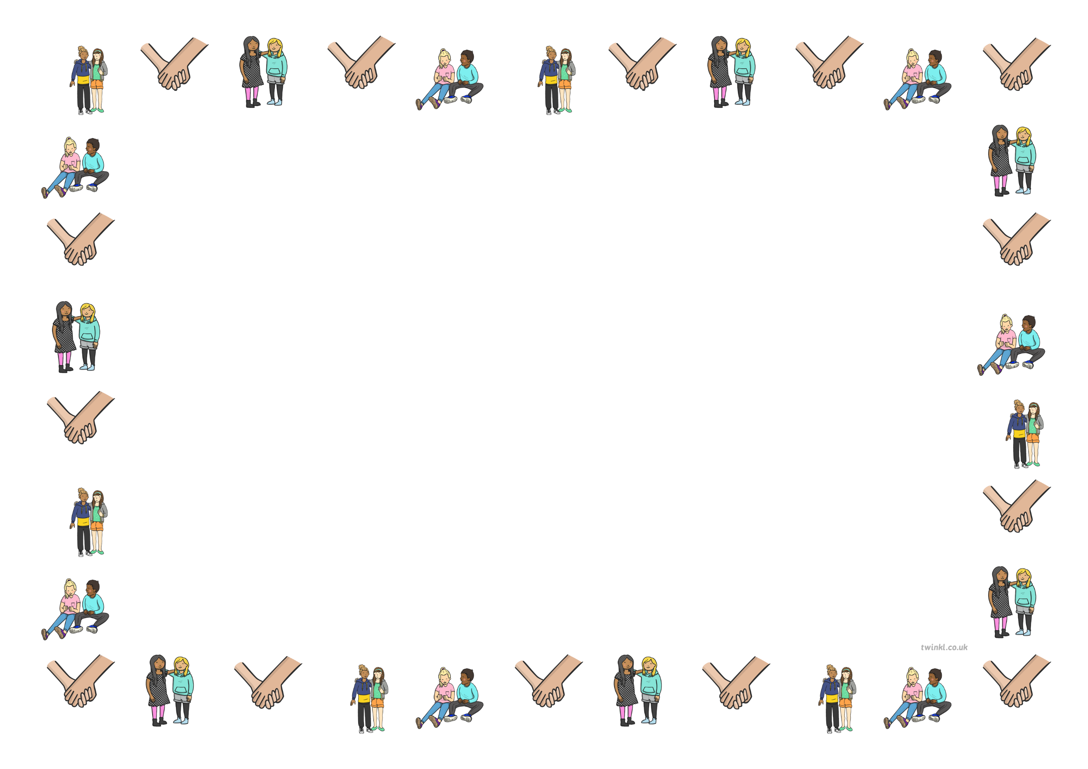

Personal, Social Emotional Development
Area of Development | Autumn 1 Autumn 2 | Spring 1 Spring 2 |  |  | Summer 1 Summer 2
PSED | RECEPTION
- See themselves as a valuable individual.
- Build constructive and respectful relationships.
- Express their feelings and consider the feelings of others.
- Show resilience and perseverance in the face of challenge.
- Identify and moderate their own feelings socially and emotionally.
- Think about the perspectives of others.
- Manage their own needs.
 |  |  | EARLY LEARNING GOALS
 |  |  | Self-Regulation | Managing Self |  | Building Relationships
 |  |  | • Show an understanding of their own feelings and those of others, and begin to regulate their behaviour accordingly.  • Set and work towards simple goals, being able to wait for what they want and control their immediate impulses when appropriate.  • Give focused attention to what the teacher says, responding appropriately even when engaged in activity, and show an ability to follow instructions involving several ideas or actions. | • Be confident to try new activities and show independence, resilience and perseverance in the face of challenge.  • Explain the reasons for rules, know right from wrong and try to behave accordingly.  • Manage their own basic hygiene and personal needs, including dressing, going to the toilet and understanding the importance of healthy food choices. |  | - Work and play cooperatively and take turns with others.  - Form positive attachments to adults and friendships with peers.  Show sensitivity to their own and to others’ needs.

Autumn Term -EYFS
Self-Regulation | Self-Regulation | Self-Regulation | Managing Self | Self-Regulation | Building Relationships | Self-Regulation
Happy | Sad | Kind | Fears/ Being Scared | Worry Monsters | Anti-bullying/ Friendships | Worried/lonely
Story Outline  The Jar of Happiness is about a little girl named Meg that wants to carry around complete happiness everywhere she goes. So she piles up a few things in a jar that she believed to embody that and takes it around everywhere with her. Even sharing her happiness with other people if needed. One day she loses the jar. The people around her show her that she doesn't need that jar to be happy or make other people happy because she can do it all on her own! I decided to add a happiness to this text set because although it is the most known felling I still think it's important to talk about the best way to make people happy is by being yourself. And that you only need yourself to be happy, no one or nothing else.  Discussion Points and Questions  Can we decide when we are happy, sad or angry?  What makes us feel differently at different times?  What makes you happy?  How can we help each other to be happy?  What are the different ways that we can tell how other people are feeling? What should we look for to tell us?  What would you put in your happiness jar?  What has made you happy today? | Story Outline  Goldilocks goes for a walk in the forest and comes upon a house. She enters and helps herself to porridge, sits in the chairs, and sleeps in the beds. Meanwhile, the bears who own the house come home and much to their surprise they discover the outcome of what Goldilocks has done to their porridge, chairs and their beds. Goldilocks wakes with a fright when she sees and hears the bears; she jumps from the bed and runs away as fast as she can. The bears never saw Goldilocks again.  Discussion Points and Questions  How did the bears feel when they got back from the walk in the forest?  Who would have to mend the broken chair? What would they need to fix it?  Would you have gone into the bear’s house? Why or why not?  Who was probably most upset in the story? Why?  What could Goldilocks have done instead of running away?  Do you think Goldilocks was a good girl or not?  How do you think the bears felt that someone was in their house without their permission?  How do the bears feel that Goldilocks ran away with no explanation or apology? | Story Outline  A book to celebrate kindness and humankind. It explores all the different ways we can be kind, by giving someone a smile, a hug, holding someone’s hand, making sure someone isn’t left out of a game or telling somebody a story.  This book encourages children to be kind and remind us all that even small acts of kindness make an impact.  Discussion Points and Questions  How can we show kindness to someone else, who isn’t showing kindness to others?  If you see someone who needs help, how could you help them?  If a new child comes to school, how can we be kind, how can we make them feel included?  If you see a classmate sitting alone, how do you think they feel? What could you do about it?  What does it mean to be helpful? How can you be helpful?  Why do you think its important to be kind?  How does being kind to someone else make you feel?  How does it feel when someone is unkind to you? | Story Outline  Scaredy Squirrel is afraid of a lot of things: bees, germs and martians.  Scardey Squirrel likes doing the same things every day and if it were his choice, he would never leave his tree. But not to worry, if danger ever does come he is fully prepared with his emergency kit. Every day he just watches and makes sure there is no danger coming toward his tree. But one day his worst nightmare comes true! Danger! Scaredy is thrown into the unfamiliar, but finds himself pleasantly surprised with the outcome. Scaredy Squirrel explores questions about the value of being prepared, the origins of fear, and the importance of new experiences.  Discussion Points and Questions  What was Scaredy Squirrel afraid of? How did he conquer his fears?  How do you conquer your fears?  What scares you? Why does this scare you?  How do you feel when you are scared?  What things do you do to help make you less scared?  Do you like to try new things?  Why do you think Scaredy Squirrel feels so good when he tries something new?  Have you ever tried something that you were afraid of but realized it wasn’t actually that bad? | Story Outline  Have you heard of the worry monsters? They eat your worries and make them disappear! Children will love this funny story featuring the friendly worry monsters, designed to help children talk about their fears. A story  to encourage children to talk about their feelings, worries and concerns.  Discussion Points and Questions  What do we mean when we say we are feeling worried?  What do you feel worried about?  Is there anything you’re feeling worried about this week?  What can we do when we are feeling worried?  Who can you talk to when you feel worried?  How can we help others that are feeling worried? | Story Outline  Gerald is a giraffe who is tall and awkward. He is best at eating leaves from tall trees. Gerald would like to be able to dance. When he attempts to join in the dancing at the Jungle Dance, the other animals make fun of him and Gerald feels he is useless. A cricket comes along and encourages Gerald to try to dance by listening to a different song. unsure at first, Gerald finds his song and finds he can dance rather well. Giraffes Can’t Dance raises questions about abilities, the abilities people have or lack, and how people discover them.  Discussion Points and Questions  What was Gerald good at? Why was he good at it?  Why did Gerald think he was bad at dancing?  Why does Gerald feel sad that he can’t dance?  Should Gerald feel sad?  Should the other animals make fun of Gerald for not being able to dance? Why or why not?  Is it right for Gerald to think that he’s useless because he can’t dance?  If there is something that you can’t do, does that make you useless or worthless?  How does the cricket help Gerald?  What are you good at? What would you like to learn to do, something that is new? | Story Outline  When three baby owls wake up to find their mother gone, they feel scared and vulnerable. But their anxieties soon prove unfounded by Mum's safe return. This book reassures and tackles the subject of temporary separation - a situation which all children are likely to experience e.g. Mum going to work or first day at Nursery/school.  Discussion Points and Questions  Have you ever felt lonely?  What can we do when we feel lonely?  Who can we talk to?  What could you do to help someone who is feeling lonely?  How did the Owl babies feel?  Why did they feel lonely and scared?  Have you ever felt scared?  How could the mum owl have stopped the babies from worrying?
Spring Term – EYFS
 |  |  | Managing Self | Managing Self | Self-Regulation | Building Relationships
 |  |  | Germs | Coronavirus | Class Rules | Autism Awareness
 |  |  | Outline  Talk to children about germs and how easily they spread. Using glitter to represent the germs show children how they are passed on through touch. Ask children how we can ensure germs aren’t passed on as easily. Demonstrate to children the correct way to wash hands, using warm water and soap for 20 seconds. Show children how doing this washes off germs and can help stop the spread of different germs and viruses, which can stop us getting poorly.  Discussion Points and outline  What are germs?  How do they spread?  How can we stop the spread of germs?  Why is it important to wash our hands properly?  What happens if we don’t wash our hands?  When should we wash our hands?  What could we do if we are unable to wash our hands at any point? | Outline  It is important to explain the coronavirus pandemic to young children in an age-appropriate way. The use of story books can be a valuable vehicle for this. Use this eBook to explore Covid-19 with EYFS children through the character, Dr. Dog. This story has been written in partnership with the London School of Hygiene and Tropical Medicine and illustrated by Lydia Monks.  Discussion points and Questions  How do you feel about coming back to school?  Do you have any worries?  What are you most worried about?  How can we keep our friends and family safe?  How do you stay safe? | Outline  Recap on classroom and school rules. Think about why they are important; why do we have rules?  Explain that rules are very important to keep us safe and happy. Having class rules that we all understand and follow means that we can all play and learn together.  Each class to work together to create 10 rules, that they agree to follow at all times.  Discussion points and Questions  Why do we have rules?  Why should we follow them?  What are the most important rules?  What should we do if we see someone, not following the rules? | Outline  Daisy and Ollie meet Theo, who is autistic. Talk to children about the week being important, that it is a time we think about how we are similar and different at the same time. Talk about Theo and that he is a little boy just like them. Explain he is also different and this is why he needs understanding and support.  Talk to children about how we are all the same in some ways and different in other ways. Discuss with children about steps they can take to support and help others who may be different.  Discussion points and Questions  How is Theo different?  What does he like doing?  What doesn’t he like doing?  Can you remember how Ollie becomes friends with Theo?  What could you do to support friends and make friends with someone like Theo?

Summer term – EYFS
Managing Self | Managing Self | Managing Self | Managing Self | Self Regulation | Self Regulation
Eat a Rainbow | Oliver’s Vegetables/fruit Salad | Lulu’s Clothes | Taking Care of our teeth | After the Fall – Being Brave | Moving up - Transition
Outline  Blake feels very sleepy with no energy and wonders why he doesn’t have the energy to play like other kids. Blake meets a friendly, magical leprechaun who takes Blake on a journey to find the pot of gold (a metaphor for good health and energy). Blake is shrunk down to tiny size and explores the colourful world of fruits and veggies. The colours (and fruits and veggies) lead to the pot of gold, where Blake feels vibrant and full of energy. The book addresses healthy eating, specifically fruits and veggies, in an engaging and positive way.  Children work together to sort a range of foods into healthy and unhealthy.  Discussion points and questions  Talk to children about the importance of being healthy and eating a well-balanced diet.  What foods do you like to eat?  Who likes vegetables?  What are vegetables?  Who likes fruit?  Can you name some fruits?  Which foods are good for us?  How can we be healthy? | Outline  Oliver likes French fries, pretty much to the exclusion of all other food. So when he goes to spend a week at his grandparents' home, they promise him his favourites only if he can find the taters in the garden. Whatever else he pulls up during the search he must eat each night for dinner. Thus Oliver is introduced to carrots, spinach, rhubarb, cabbage, beets, and peas, all of which he thinks are delicious.  Chikldren to talk about their favourite foods, both healthy and unhealthy. Talk about where certain foods come from and how they grow. Looking at growing in gardens, farms and allotments.  Discussion points and Questions  Who likes vegetables?  How often should we eat vegetables?  Where do fruit and vegetables come from?  How do they grow?  What do they need to grow? | Outline  Lulu loves clothes and getting dressed. Throughout the book lulu tries on lots of different clothes and ways of putting them on. For example, She wears a stripy top, armbands to go swimming, an apron to do the washing up, a cycle helmet, a party dress, and finally her furry dressing gown. Each involves a different textured material, bow to tie, or zip to do up and take part in.  Talk to children about getting dressed and how important it is to be as independent as possible when getting ready for school, PE and bedtime.  Discussion Points and Questions  Why is it important to get dressed independently?  What can we do if we need help?  When do we get dressed? | Outline  Pony learns how to brush his teeth by watching Dad. This simple story follows the steps of brushing from choosing a toothbrush to rinsing your mouth.  Talk to children about looking after ourselves and in particular our Teeth. Use People who help us; Dentist PPT.  Discussion Points and Questions  How can we look after our teeth?  When should we brush our teeth?  How many times a day should we brush our teeth?  What happens if we don’t brush our teeth?  Who helps us to take care of our teeth? | Outline  After the Fall follows Humpty Dumpty, an avid bird watcher who loves to be high up on the city wall. But after his fall, Humpty is terrified of heights and can no longer do his favourite things. He finally pulls together the courage to climb back up the wall. Based on the beloved nursery rhyme, this inspiring and unforgettable picture book will encourage even the most afraid to overcome their fears, learn to get back up—and reach new heights.  Discussion Points and Questions  Are you scared about anything?  Has anything ever put you off doing something?  How have you been brave?  How can we help others be brave?  When might we need to be brave?  What can we do if we see someone who is feeling frightened?  How can we help?

